Project Report

The app’s focus is primarily targeted towards food enthusiasts and other individuals who enjoy cooking as a practice or as a habitual necessity. The app is intended to service different types of recipes, depending on a particular user’s type of input. The searched query returns a result populating the list of items from the recipe puppy API. Based on the ingredient that is searched, a web view of the various types of recipes corresponding to that ingredient are listed in a web browser.

The app makes API calls to this recipe puppy API and the matching results are fetched and displayed to the user. In addition to that, if in case a user wants to write a custom recipe for a particular meal then that task can be performed by filling in the fields after clicking on the favorite button. The app focusses on delivering variety of recipes based on the user queries.

Screenshots:

When the app is launched, the user is prompted to view this screen:

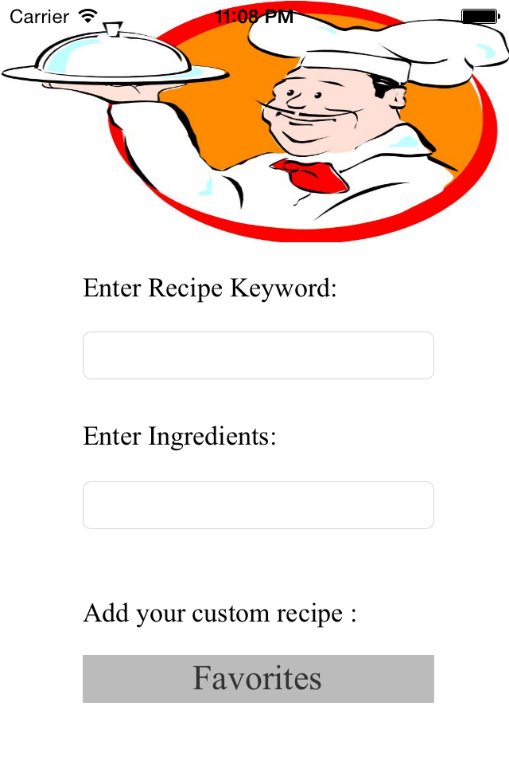

Second screen:

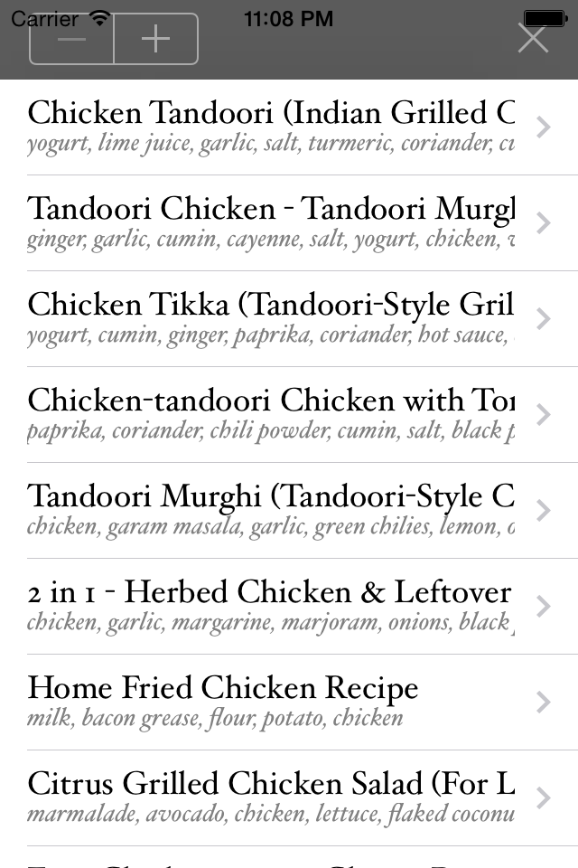

Third screen:

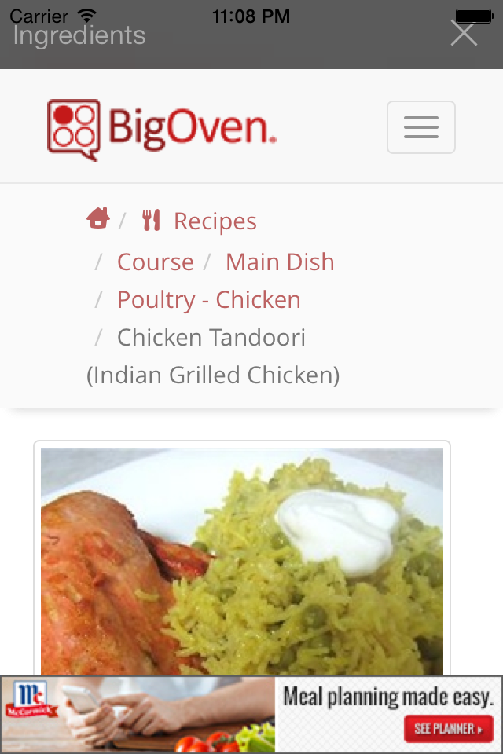

Fourth screen:

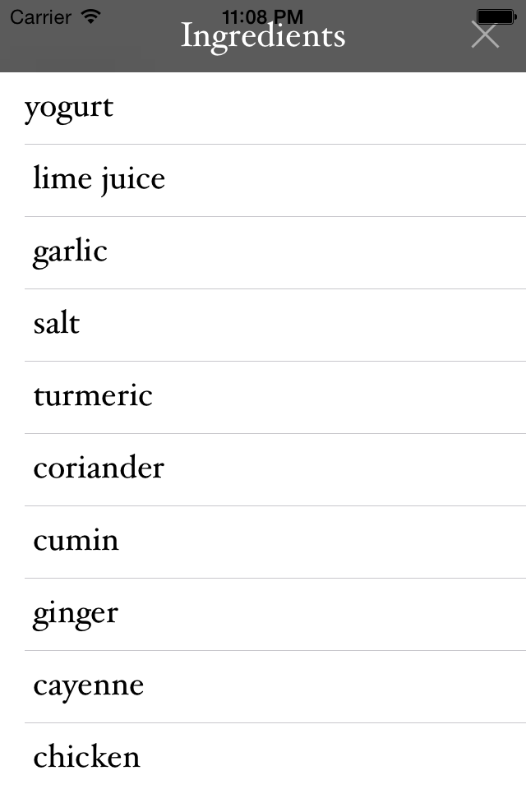

Fifth screen:

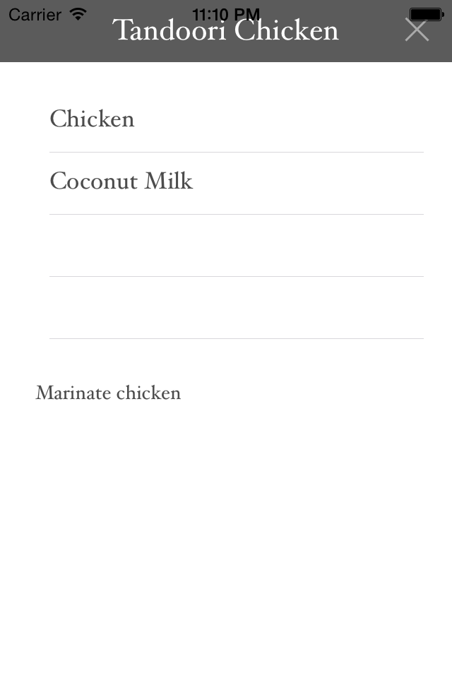

Screen6:

